**integrate Allure Report for Playwright E2E tests in Angular 17** 🚀.

**✅ Step 1: Install Allure Packages**

In your Angular 17 project:

npm i -D allure-playwright

<https://www.youtube.com/watch?v=D3FnWlxE0HU>

<https://www.npmjs.com/package/allure-playwright>

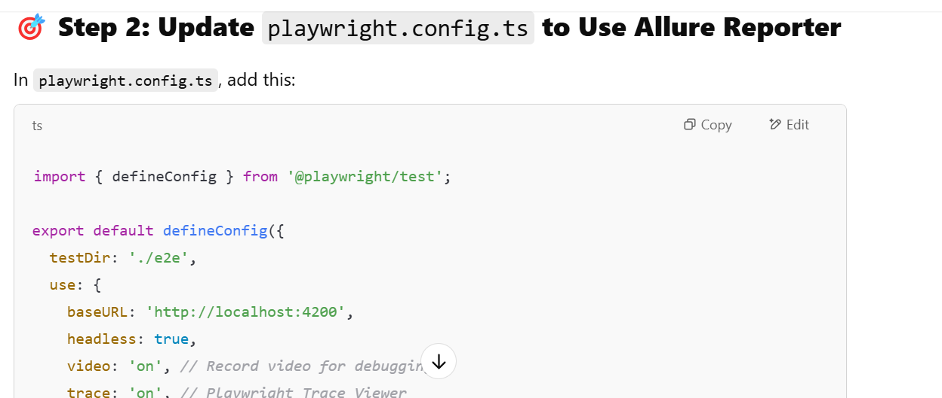

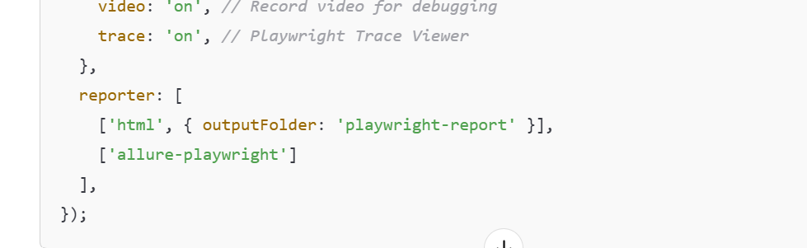

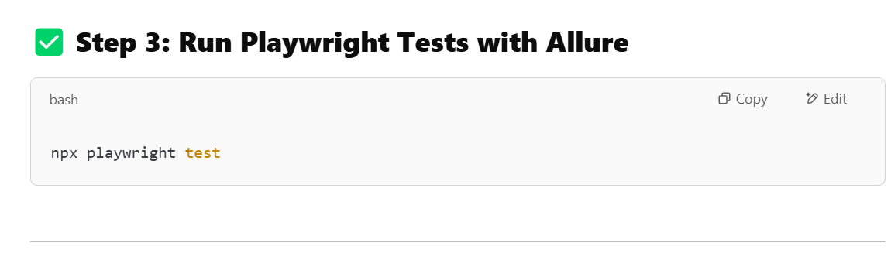**🎯 Step 4: Generate Allure Report**

npx allure generate allure-results –clean

**🚀 Step 5: Open Allure Report**

npx allure open

**🎯 You can now see:**

* 📜 **Test Details**
* ✅ **Passed/Failed Tests**
* 📽️ **Video Recording**
* 🔍 **Playwright Trace Viewer**
* 📈 **Performance Metrics**

**Step 6: Add Allure Report to GitHub Actions CI**

In your .github/workflows/playwright.yml, add this step:

Use this

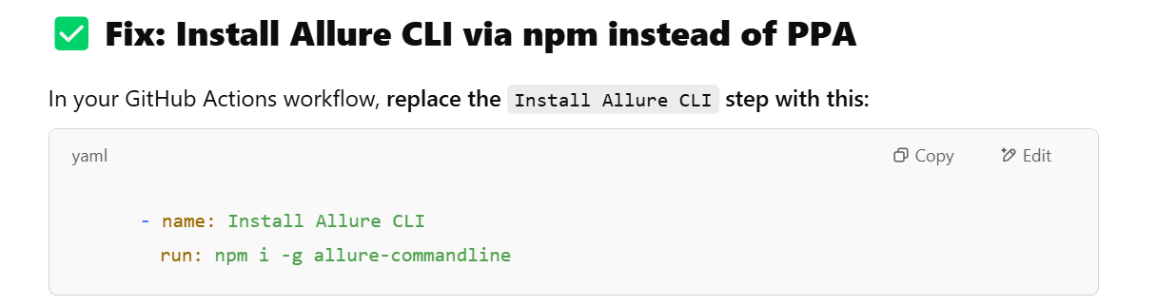

(not the below one)

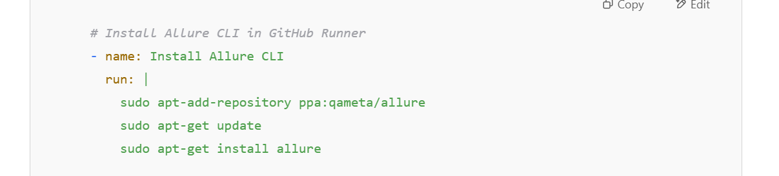

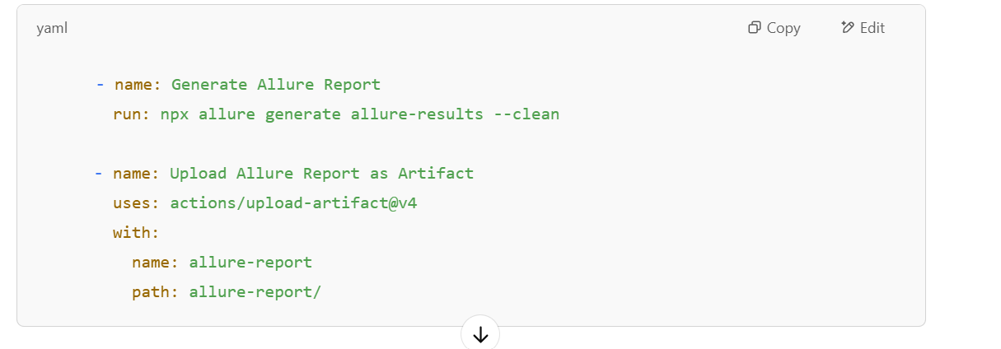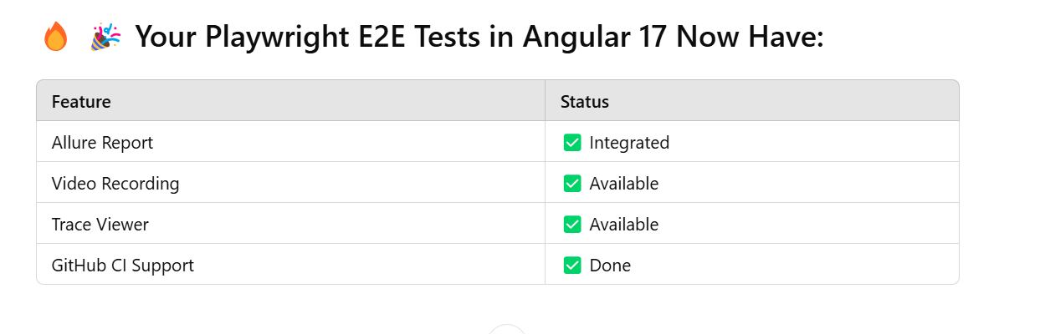

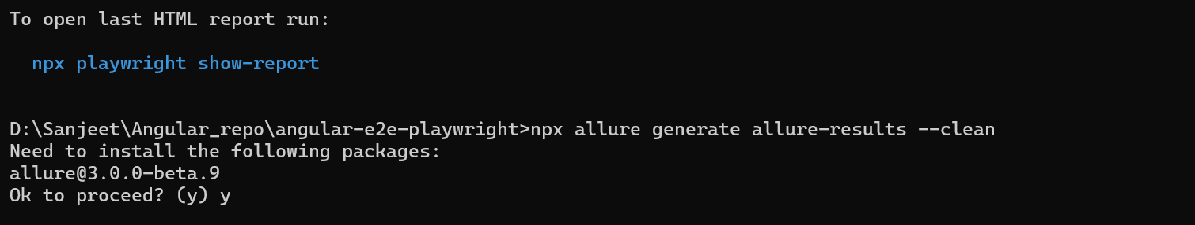

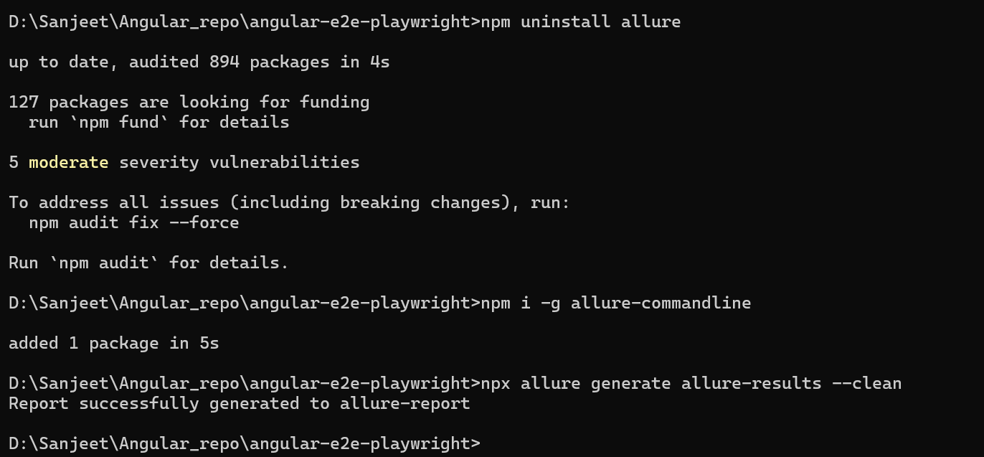

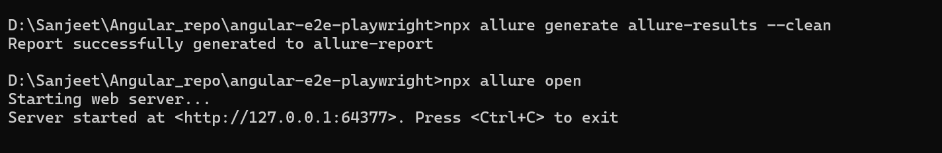

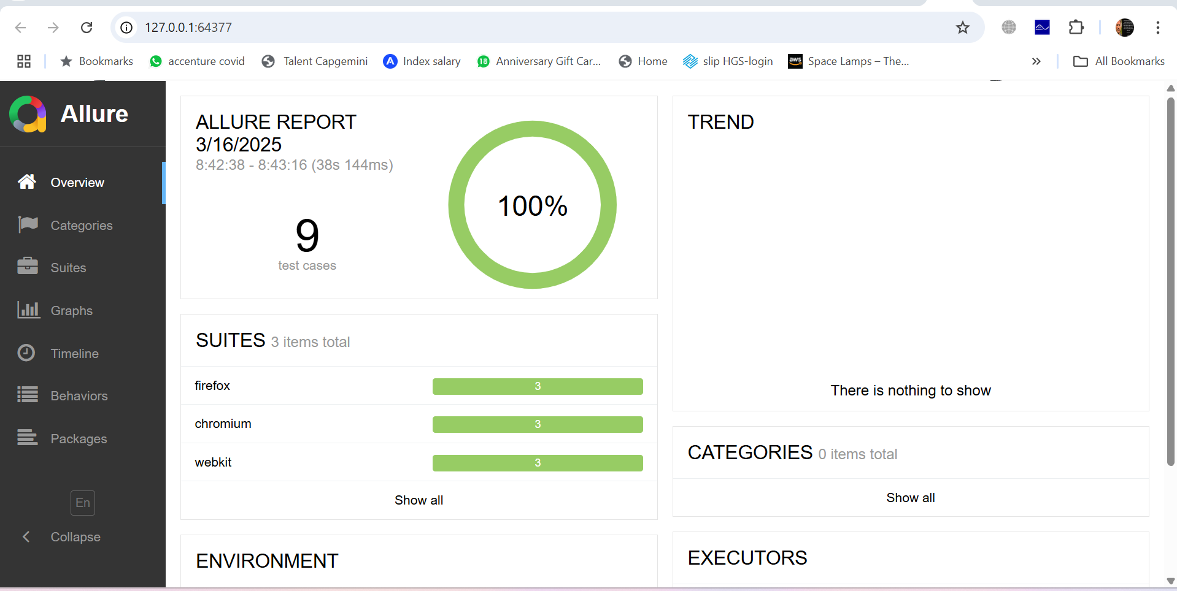

**✅ What Was the Issue?**

* Allure v3 (beta) CLI has breaking changes
* The stable **Allure Command-Line Tool** works perfectly

Would you like me to show **how to auto-upload the Allure report to GitHub Pages or S3 Bucket for public access?**